



ML Ops & Containerization
LAB MANUAL

Disclaimer: The content is curated from online/offline resources and used for educational purpose only
GitHub Repository Management – Personal Expense Tracker
Objective
To create and manage a GitHub repository, connect a local Git repository to GitHub, and synchronize project files using Git commands.
Problem Statement
A software developer has created a Personal Expense Tracker application to record daily expenses. To securely store the project, maintain version history, and access it from multiple devices, the developer wants to upload the project to GitHub.
Requirements
Software
- Git
- GitHub Account
- Visual Studio Code
- Internet Connection
Project Files
- README.md
- expense_tracker.py
Procedure
Step 1: Create a Repository on GitHub
- Login to GitHub.
- Click New Repository.
- Repository Name: ExpenseTracker
- Select Public.
- Click Create Repository.
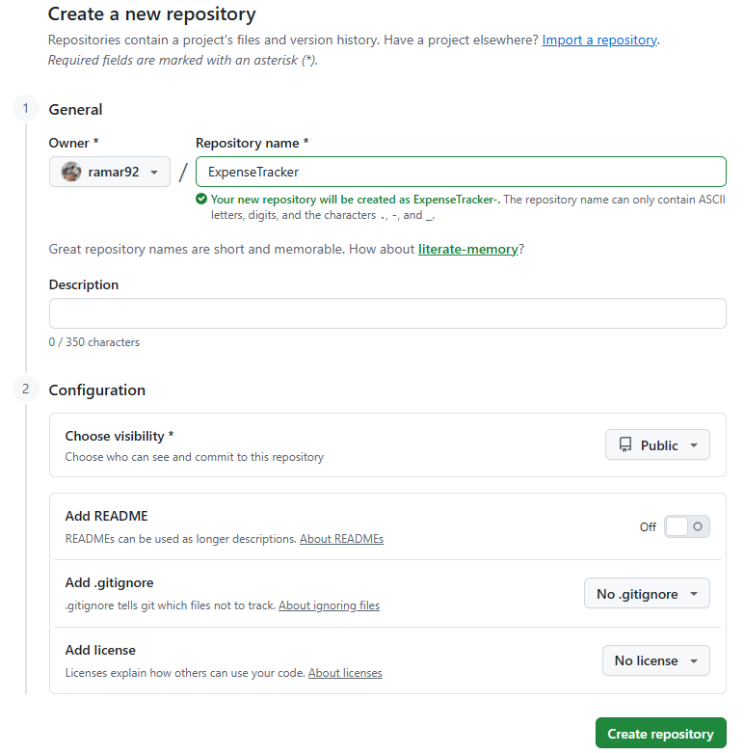
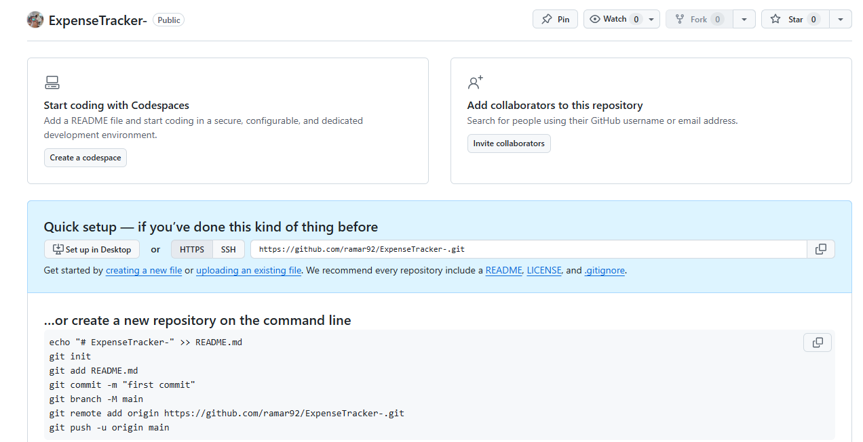
Created.

Step 2: Create Local Project
mkdir ExpenseTracker
cd ExpenseTracker
git init
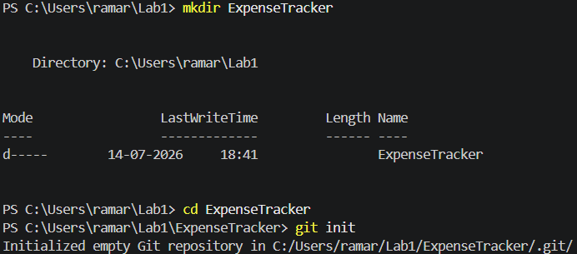
Step 3: Create README.md
# Personal Expense Tracker
A Python application to record daily expenses.

Step 4: Create expense_tracker.py
amount = float(input("Enter Expense: "))
print("Expense Recorded:", amount)

Step 5: Commit Files
git add .
git commit -m "Initial Expense Tracker"
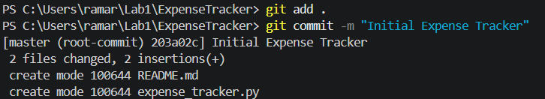

Step 6: Connect GitHub Repository
git remote add origin https://github.com/ramar92/ExpenseTracker-.git
Verify
git remote -v
Step 7: Push Repository
git branch -M main
git push -u origin main
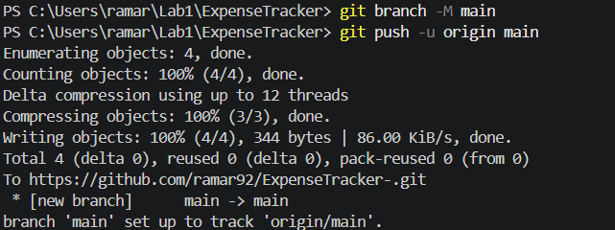
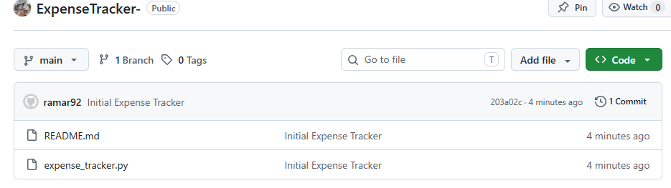
Step 8: Modify Project
Before Modfiy
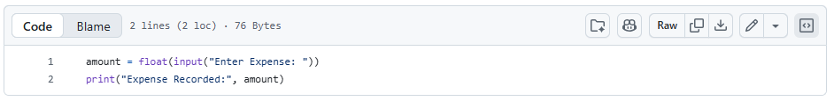

Add category support.
category = input("Enter Category: ")

Commit
git add .
git commit -m "Added expense category"
git push
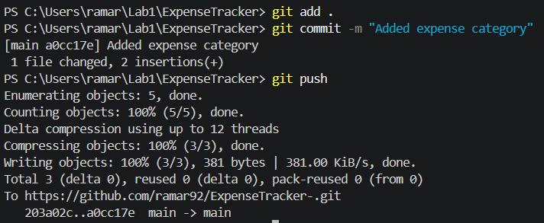
After this,
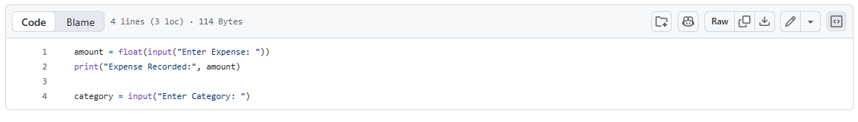
Step 9: Pull Latest Changes
git pull origin main
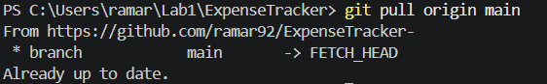
Conclusion
Students learned to create a GitHub repository, connect a local repository, push project files, and synchronize updates between local and remote repositories.

